**Project Plan**

November 1, 2021

Team lead name

S. Name

Mi. Name

L. Name

P. Name



**Table of Contents**

Section I: Problem Statement 1

Section II: Project Mission Statement 1

Section III: Project Objectives !

Section IV: Project Work Requirements 2

Section V: Exit Criteria 5

Section VI: Work Breakdown Structure 6

Section VII: Milestones 6

Section VIII: Working Schedule 7

Section IX: Required Resources 7

Section X: Major Contributors 8

Section XI: Control System 9

Section XII: Risk Table 11

# **Section I: Problem Statement**

Mission Accomplished is a 501(c)(3) nonprofit organization that currently serves the Greater Austin area. The organization’s primary goal is to provide resources and assistance to Austin’s homeless community by providing a mobile laundry service.

Recently the organization received funding to increase its mobile laundry service to include multiple locations three times a week. While this funding is a testament to the organization’s mission, there are three major issues affecting the organization’s ability to offer this increase of services.

1. The organization lacks the manpower needed to offer services three times in a week because it has difficulty recruiting and maintaining volunteers on a long-term basis.

2. The organization has successfully collected data on supporters, volunteers, and the homeless population they have served; however, they have not been able to create a strong visualization of this data to aid its volunteer and funding efforts.

3. The organization has limited administrative support which has created difficulty in researching and applying for local and national grants and funding.

# **Section II: Project Mission Statement**

The project team’s mission is to develop a client-ready package that can be implemented by Mission Accomplished to increase volunteer recruitment and retention as well as the organization’s ability to submit grant applications for potential funding.

The goals for this project include the following:

• We will improve the social media presence of Mission Accomplished on Facebook and Instagram to increase volunteer enrollment.

• We will increase funding opportunities by improving the organization’s ability to meet grant deadlines and provide data visualization of their outreach to potential donors.

• We will increase the organization’s volunteer participation through a solicitation template and volunteer retention through improved training materials.

# **Section III: Project Objectives**

The objectives for our project include the following:

• We will increase social media followers on Facebook and Instagram by 20% over a 30-day period

• We will increase the outreach of Facebook and Instagram posts by 35% over a 30-day period and will provide bi-weekly Insight reports to gauge post performance within the 30-day timeline.

• We will develop data visualization of organization’s outreach over the last fiscal year to be used to increase funding by 5% by December 31, 2022.

• We will compile a list of grants and funding opportunities over one calendar year, so the client is able to track potential funding sources and increase grant applications to 5 per calendar year.

• We will increase volunteer enrollment by 20% of the current number by January 1, 2022, so the organization has the manpower to offer mobile laundry services three times a week.

• We will create a Standard Operating Procedure manual for volunteer training and decrease onsite intake time by 25% (roughly 5-7 minutes) to provide a cohesive volunteer experience and contribute to volunteer retention.

# 

# **Section IV: Project Work Requirements**

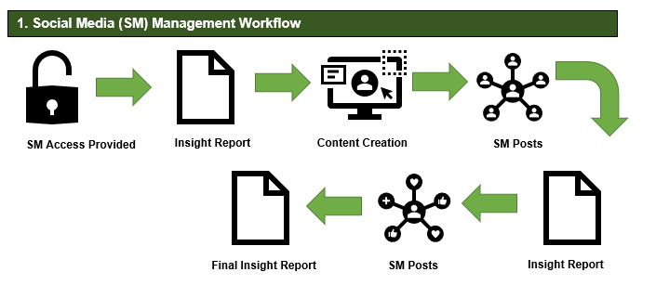

1. Social Media Management

* 1. Our client will provide access to the organization’s Facebook and Instagram accounts.
  2. Our team will pull an initial Insights report from both Facebook and Instagram. This will provide us details on the organization’s current social media presence including current followers, number of posts, and the number of views each post has received. We will use this as our baseline for social media campaigning
  3. Our team will design one-month of social media posts. These posts will promote upcoming events, volunteer sign-ups, and details about the organization's mission and outreach programs. The purpose of these posts is to increase the organization’s online visibility and volunteer solicitation.
  4. Our team will provide bi-weekly (9a total of two) insight reports while running the social media campaigns for one-month. This will show the increase of views and followers for the organization.
  5. At the end of our social media campaign, we will provide a final insight report and expect to show a 20% increase in followers and a 35% increase in views for the organization on Facebook and Instagram.

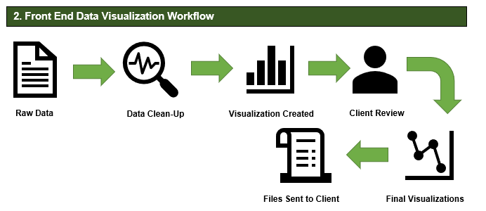

2. Front-End Data Visualization

* 1. Our client will provide raw data on the current outreach of their organization. This will include data on homeless served, including age, race, veteran status, and other biographical data, as well as data such as pounds of laundry processed and number of volunteers.
  2. This data will be analyzed and cleaned, which includes removing any irrelevant data.
  3. Our team will use the cleaned data to provide statistics on the organization's outreach. This data will be used to create front-end visualizations, such as charts and graphs.
  4. We will provide a first series of visualizations to our client for their review and approval. Upon feedback our team will finalize the visualizations.
  5. The front-end visualizations will be provided to the client as editable documents and image files. The image can be used by the client when applying for grants and donations. In addition, the data visualizations can be updated as needed for future funding applications or solicitations.

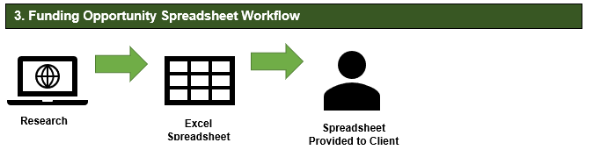

3. Funding Opportunities Spreadsheet

* 1. Our team will research local and national funding opportunities that our client qualifies to apply.
  2. Information found will be added to an Excel spreadsheet. This information will include the funding agency, general requirements, and application due date.
  3. Our client will be able to use this spreadsheet to increase their funding application over the next calendar year.

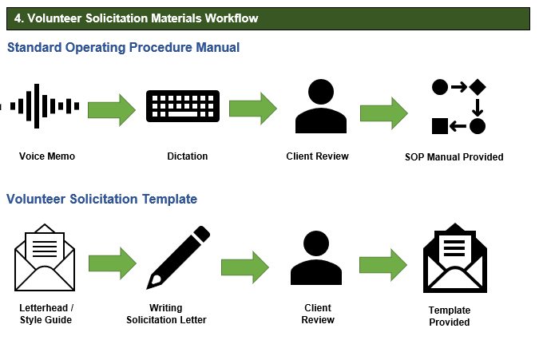

4. Volunteer Recruitment & Retention

* 1. Our client will provide a voice memo detailing the organization's current intake process for its laundry events.
  2. Our team will dictate this memo and provide the client with a drafted procedure manual.
  3. Upon client’s approval of the initial data, our team will create a standard operating procedure manual for incoming volunteers. Our hope is to increase volunteer retention by providing proper training materials.
  4. Our client will provide the organization's letterhead and style guide information so that our team will create a solicitation template that our client can use to send to local organizations who may need community service hours.

# **Section V: Exit Criteria**

|  |  |
| --- | --- |
| **Milestone** | **Criteria** |
| Social Media Management | Social media management will be carried out over a 30-day period. Our team will provide an initial Insight report, so the client is aware of the current social media presence on Facebook and Instagram. Over a 30-day period, our team will post content on Facebook and Instagram and provide bi-weekly (a total of two) additional Insight reports to show the traffic that is created through these posts. We define traffic as likes, shares, and other interactions. Posts will focus on promoting the organization's mission, upcoming events, and volunteer sign-ups. **At the end of the 30-day period, our team will provide a final insight report to show a 20% increase in followers and a 35% increase in views for the organization on Facebook and Instagram**. |
| Front-End Data Visualization | The front-end data visualization will include a series of two deliverables, both including charts and graphs of the organization’s current outreach. As each series of data visualization is completed, it will be reviewed by the project manager. The project manager will be responsible for providing the drafts to the client for review and approval. **After receiving client’s feedback and making any necessary changes or edits, the project manager will provide the final documents, in both an editable document and image files to client for use in grant applications and other solicitations or social engagement.** . |
| Funding Opportunity Spreadsheet | Once the project manager has signed off on the funding opportunity spreadsheet, the Excel document will be provided to the client. **Our client will be able to use this spreadsheet to increase their submitted applications for the next calendar year.** |
| Volunteer Retention and Recruitment Materials | The volunteer retention and recruitment materials will include two deliverables. The first a standard operating procedure manual to assist in training volunteers and the second a volunteer solicitation letter template. As each item is completed, it will be reviewed by the project manager. The project manager will be responsible for providing the drafts to the client for review and approval. **Once our client receives final materials, they will be able to improve volunteer retention by providing adequate training materials and solicit new volunteers from local organizations seeking community service hours.** |
| Final Client Meeting | Once all deliverables have been provided to the client, the project management team will participate in a final client meeting. **During this meeting we will gain feedback on the workflow, communication, and overall performance during the project.** |
| Final Presentation | Once the client has signed off on deliverables, the project management team will work on creating a presentation for the project. **The presentation will be reviewed by all team members and upon our unanimous approval it will be submitted on blackboard by the PM.** |

# 

# **Section VI: Work Breakdown Structure**

# 

# **Section VII: Milestones**

.

|  |  |  |
| --- | --- | --- |
| **ID** | **Milestone Description** | **Date** |
| M1 | Project plan completed & approved | Nov 9, 2021 |
| M2 | Project start date | Nov 9,2021 |
| M3 | Client provides data and login credentials | Nov 9,2021 |
| M4 | Social media management commences, Insight reports provided | Nov 12, 2021 |
| M5 | Client provides voice memo of intake process | Nov 12. 2021 |
| M6 | Project update meeting with client | Nov 16, 2021 |
| M7 | First series of data of visualization is provided | Nov 18,2021 |
| M8 | First draft of SOP is provided | Nov. 20, 2021 |
| M9 | Second social media Insight reports provided | Nov 26, 2021 |
| M10 | Second series of data visualization is provided | Nov 29,2021 |
| M11 | SOP is finalized | Nov 29, 2021 |
| M12 | Project update meeting with client | Nov 30, 2021 |
| M13 | Final social media insights report provided | Dec 3, 2021 |
| M14 | Grants & Funding spreadsheet provided | Dec 10, 2021 |
| M15 | Letter / Email template for volunteer solicitation provided | Dec 10, 2021 |
| M16 | Final meeting with client / project close-out | Dec 13, 2021 |
| M17 | Test data and results, tweak outputs, and project presentation | Dec 14, 2021 |

# **Section VIII: Working Schedule**

|  |  |  |  |
| --- | --- | --- | --- |
| **Task Description** | **Start** | **End** | **Duration** |
| **A1.1 Social media management** | **11/9/2021** | **12/10/2021** | **30 days** |
| A1.2 Social media posts | 11/9/2021 | 12/10/2021 | 30 days |
| A1.3 Insight Reports | 11/9/2021 | 12/9/2021 | 30 days |
| A1.4 Draft 12 posts for Facebook (review & revise) | 11/9/2021 | 11/16/2021 | 1 week |
| A1.5 Draft 12 posts for Instagram (review & revise) | 11/9/2021 | 11/16/2021 | 1 week |
| A1.6 Insights Report (weeks 1-2) | 11/9/2021 | 11/23/2021 | 2 weeks |
| A1.7 Insights Report (weeks 3-4) | 11/9/2021 | 11/23/2021 | 2 weeks |
| A2.1 Get approval for Facebook posts (finalize) | 11/16/2021 | 11/20/2021 | 4 days |
| A2.2 Get approval for Instagram posts (finalize) | 11/16/2021 | 11/20/2021 | 4 days |
| A2.3 Compile report data for weeks 1-2 | 11/23/2021 | 11/26/2021 | 3 days |
| A2.4 Compile report data for weeks 3-4 | 12/7/2021 | 12/10/2021 | 3 days |
| A2.5 Clean all data and create visualization | 12/10/2021 | 12/13/2021 | 3 days |
| A3.1 Publish 6 Facebook posts for weeks 1-2 | 11/9/2021 | 11/23/2021 | 2 weeks |
| A3.2 Publish 6 Instagram posts for weeks 1-2 | 11/9/2021 | 11/23/2021 | 2 weeks |
| A3.3 Publish 6 Facebook posts for weeks 3-4 | 11/24/2021 | 12/10/2021 | 2 weeks |
| A3.4 Publish 6 Instagram posts for weeks 3-4 | 11/24/2021 | 12/10/2021 | 2 weeks |
| A4.1 Analyze data for weeks 1-2 | 11/23/2021 | 11/26/2021 | 3 days |
| A4.1 Analyze data for weeks 3-4 | 12/7/2021 | 12/10/2021 | 3 days |
| **B1.1 Funding opportunities** | **11/10/2021** | **12/10/2021** | **30 days** |
| B1.2 Data visualization | 11/10/2021 | 11/18/2021 | 1 week |
| B1.3 Funding spreadsheet | 11/10/2021 | 12/10/2021 | 30 days |
| B1.4 Create data visualization for past year of funding | 11/10/2021 | 11/18/2021 | 1 week |
| B2.1 Gather information on previous grants | 11/10/2021 | 11/18/2021 | 1 week |
| B2.2. Get team approval of data visualizations | 11/18/2021 | 11/21/2021 | 3 days |
| B2.3 Conduct research for 5-15 grants | 11/10/2021` | 11/25/2021 | 2 weeks |
| B2.4 Publish data visualization for final project | 11/21/2021 | 11/28/2021 | 1 week |
| B2.5 Compile spreadsheet of grants | 11/26/2021 | 12/10/2021 | 2 weeks |
| **C1.1 Volunteer recruitment and retention** | **11/10/2021** | **12/10/2021** | **30 days** |
| C1.2 Volunteer enrollment | 11/10/2021 | 12/10/2021 | 30 days |
| C1.3 Volunteer training material | 11/10/2021 | 12/10/2021 | 30 days |
| C1.4 Draft a solicitation letter template | 11/10/2021 | 11/20/2021 | 10 days |
| C1.5 Draft a solicitation email template | 11/10/2021 | 11/20/2021 | 10 days |
| C1.6 Provide templates to client for recruitment | 11/20/2021 | 11/27/2021 | 1 week |
| C2.1 Draft intake process from voice memo | 11/12/2021 | 11/20/2021 | 1 week |
| C2.2 Get approval on SOP for intake process | 11/20/2021 | 11/27/2021 | 1 week |
| C2.3 Provide client with SOP for volunteer training | 11/28/2021 | 12/4/2021 | 1 week |

# **Section IX: Required Resources**

|  |  |  |
| --- | --- | --- |
| **People** | | |
| **Resource** | **Contact Information** | **Project Role** |
| Shequita Brown Mckenzi | Brownmckenzs1@gator.uhd.edu | Project Manager |
| Sara Escamilla-Tristan | escamillas@gator.uhd.edu | Project Team Member |
| **People** |  |  |
| **Resource** | **Contact Information** | **Project Role** |
| Michael Oluwatomi Efenaro | Efenarom1@gator.uhd.edu | Project Team Member |
| Linda Herrera | Herreral@gator.uhd.edu | Project Team Member |
| Pushpalatha Solligi | solligip1@gator.uhd.edu | Project Team Member |
| Ebonie Trice | info@mission-accomplished.com | CEO & Founder |
| Dr. Jillian A. Hill | hillj@gator.uhd.edu | Project Sponsor |

|  |  |
| --- | --- |
| **Technology** | |
| **Software** | **Purpose** |
| Microsoft Excel | A client-ready excel spreadsheet of funding opportunities will be provided |
| Tableau | Tableau will be the program used to create data visualization |
| Zoom | Zoom will be used for all client and team meetings |
| Monday.com | Monday.com will be the primary project management software |
| Google Drive | Google Drive will be used to share files and collaborate on product deliverables. |
| Microsoft Outlook | Outlook will be used to exchange emails |
| WhatsApp | Used as primary source of communication among team members |
| GroupMe | Used as primary source of communication between project manager and client |
| Canva.com | Canva will be used to design social media posts |

# **Section X: Major Contributors**

**P = Primary Responsibility S = Support Blank = No Responsibility**

|  |  |  |  |  |  |
| --- | --- | --- | --- | --- | --- |
| **Linear Responsibility Chart** | | | | | |
| **Task ID** | **Project Contributors** | | | | |
| **Shequita** | **Sara** | **Linda** | **Pushpalatha** | **Michael** |
| A1.1 |  | P |  |  |  |
| A1.2 |  | P |  |  |  |
| A1.3 |  | P |  |  |  |
| A1.4 |  | P |  |  | S |
| A1.5 |  | P |  | S | S |
| A1.6 |  | P |  |  | S |
| A1.7 |  | P |  |  | S |
| A2.1 |  | P |  |  |  |
| A2.2 |  | P |  |  | S |
| A2.3 |  | P |  |  | S |
| A2.4 |  | P |  |  | S |
| A2.5 |  |  |  | P |  |
| A3.1 |  | P |  |  | S |
| A3.2 |  | P |  |  | S |
| A3.3 |  | P |  |  | S |
| A3.4 |  | P |  |  | S |
| A4.1 |  |  |  | S | P |
| A4.2 |  |  |  | P |  |
| **Linear Responsibility Chart** | | | | | |
|  | **Project Contributors** | | | | |
| B1.1 | P |  |  |  | S |
| B1.2 |  |  |  |  | P |
| B1.3 | P |  |  |  |  |
| B1.4 |  |  |  |  | P |
| B2.1 | P |  |  |  |  |
| B2.2 |  |  |  | P |  |
| B2.3 | P |  |  | S | S |
| B2.4 |  |  |  | P |  |
| B2.5 | P |  |  | S | S |
| C1.1 |  | S | P |  | S |
| C1.2 |  | S | P |  | S |
| C1.3 |  | S | P |  | S |
| C1.4 |  | S | P |  | S |
| C1.5 |  | S | P |  | S |
| C1.6 | P |  | S |  |  |
| C2.1 |  | S | P |  | S |
| C2.2 |  | S | P |  | S |
| C2.3 | P |  | S |  |  |

# **Section XI: Control System**

Information to be added by Michael

**Quality Control System**

During the period of this project, we will be developing several deliverables that will not only create the needed output, but their structure will conform with the specific guidelines and requirements stated by the client. As a result, during the development of the entire workflow chart, we had to put in place an adequate quality assurance system to be able to keep track of the progress of the entire project.

And, to ensure we have an effective workflow, quality control was built into the development schedule. As each step is completed in the workflow development process, the project manager and the client review the output before the project enters the next phase. The approval of every stage in the development process immediately kicks starts the next agenda. The client for this project is the CEO of Mission Accomplished.

In addition, as the front-end visualization development milestone and full product documentation is complete, a full review will be conducted by the project manager. And when this is completed, the product will be sent to the client for a full review before being accepted.

**Change Control System**

As a result of a close communication between the team’s contact, Project Manager, and the Client, we were able to develop a well-defined scope for the project. The scope subsequently was discussed and implemented into the work schedule. And should there arise any additional changes to the scope, there will be a control process to handle the unexpected changes.

Also, all requests for any change to the scope of the project either from the Client or any member of the team will have to pass through the Project Manager for review before a decision is made. And the project manager will bring this up in our weekly meeting for general review and action taken. The client may request for a scope change or a team member or the entire team might request for work to be removed due to time constraint if need be. As soon as the Project Manager has been notified of all proposed changes, it will be the responsibility of the Project Manager to look critically at the work schedule to determine if it is possible to adjust the project scope within the time frame given. The project schedule has been built in a way to accommodate any scope changes to accommodate unforeseen circumstances during the project.

And based on the limited time frame for the project, the project Manager will decide whether changes are to be made to the WBS and/or work schedule. This will be brought to the team and discussed and then the project manager makes the final decision. And all impacted parties will be informed of the changes within the time frame for the next phase of the project to commence.

**Conflict Control System**

Also, aconflict resolution structure was put in place for the project. Should a conflict arise between team members, the project manager shall mediate between parties involved and bring a solution or compromise between the parties involved. All parties involved will be given the opportunity to express their opinions, this will be discussed, and the project manager shall then inform the whole team, if need be, or simply resolve matters to de-escalate any tension within the team.

In addition, should the client propose any change(s) to the project, as soon as the project manager has been notified by the client, the project manager shall present this to team members, this will be discussed as a team, and if the change is manageable, it will be implemented, and the client will be informed by the project manager. And if the change is a major one that will not fit into the time frame for the project, and, or may require resources that are unavailable to accomplish it, the proposed change will be ruled out and the project manager shall inform the client about the decision.

Furthermore, at the start of the project, the project manager had addressed the need for the team and client to work as a unit towards the same goal with mutual respect. And all conflicts are expected to be resolved for the sake of achieving our set goals and to foster better relationships among the team.

# **Section XII: Risk Table**

|  |  |  |  |  |
| --- | --- | --- | --- | --- |
| **Risk** | **Probability** | **Impact** | **Trigger** | **Contingency** |
| Technical work exceeds scheduled duration | Medium | High | One week before a milestone is not expected to be reached by deadline | Additional week scheduled to create technical documentation can be reduced if necessary. |
| Full or temporary loss of project team member | Low | High | 24 hours after a team member has an emergency leading to withdrawal from the program or notifies PM of an illness | The team consists of members with diverse skill set backgrounds. Twenty-four hours after a team member drops the course or notifies of an illness, the program schedule will be reassessed, and project responsibilities may be shared or reassigned.  If the withdrawal impacts certain aspects of the project so that it can no longer be continued, the Project Manager will inform the client and reduce the scope of the project to meet the required timeframe. |
| Loss or corruption of data | Medium | Medium | Immediately after file is deleted, overwritten, or corrupted in shared folder | Team members will back up versions on their local drive. Files are shared via emails as well with necessary attachments to make it easy to retrieve files from multiple sources in case the original file is corrupted in the shared folder on google drive. |
| Quality errors leads to non-acceptance of client deliverable | Low | Medium | Within 48 hours of client rejecting deliverable or fails to sign off | If the issue is not mitigated by following a quality control plan, the Project Manager will accept detailed feedback from the client and work with the project team member to resubmit. Then, the schedule will be adjusted to reflect buffer time allocated for technical documentation creation and review. |